CENWP-OD-B 06 July 2024

MEMORANDUM FOR THE RECORD

SUBJECT: 24BON019 MFR WA Shore UMTJ RB1 Pacific Lamprey Mortality

On the morning of 06 July 2024, Project Biologists discovered one adult Pacific Lamprey mortality in Rest Box 1 of the Washington Shore Upstream Migrant Transportation Junction LPS (WA Shore UMTJ LPS RB1). The fish was measured, scanned for PIT tags, inspected, and returned to the river.

- Species – Pacific Lamprey (Entospehnus tridentatus)
- Origin – Unknown
- Length – 68.58cm
- Marks and tags – None
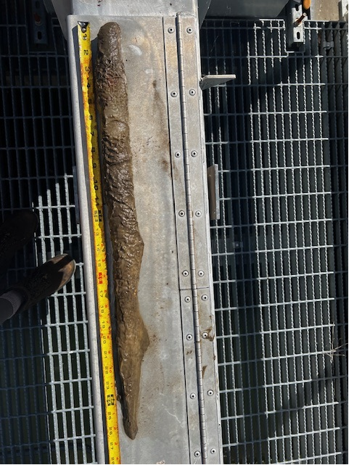
- Marks and Injuries found on carcass – Fungus, no other marks
- Cause and Time of Death – Unknown
- Future and Preventative Measures – N/A

Sincerely,
Project Fisheries

